Patrick Kevorkian

CSC 424 Final Project

Blog Database

12/06/15

**#Creation Script**

# Dump of table comments

# ------------------------------------------------------------

DROP TABLE IF EXISTS `comments`;

CREATE TABLE `comments` (

`comment_id` int(10) unsigned NOT NULL AUTO_INCREMENT,

`c_username` varchar(30) DEFAULT NULL,

`body` varchar(5000) DEFAULT NULL,

`post_id` int(10) DEFAULT NULL,

`dateTime` datetime DEFAULT NULL,

PRIMARY KEY (`comment_id`)

) ENGINE=InnoDB AUTO_INCREMENT=16 DEFAULT CHARSET=latin1;

LOCK TABLES `comments` WRITE;

/*!40000 ALTER TABLE `comments` DISABLE KEYS */;

INSERT INTO `comments` (`comment_id`, `c_username`, `body`, `post_id`, `dateTime`)

VALUES

(1,'Dr. Kevorkian','Andy nobody cares....',1,'2010-03-15 00:00:00'),

(2,'Dr. Kevorkian','Me Hoy Minoy!',6,'2015-05-27 00:00:00'),

(3,'MaidOfOrleans','Well thats just awful, ill do something about that. ',8,'1862-08-19 00:00:00'),

(4,'GsaveTheQueen','You sir are the worst monarch ive ever seen. I am not amused.',4,'1977-01-10 00:00:00'),

(5,'EmperorSidious','Im rooting for Javert! You criminal. ',8,'1862-08-19 00:00:00'),

(6,'CommonSense','Where?',7,'1779-10-14 00:00:00'),

(7,'LibertyOrDeath','On the back, you just cant see it.',7,'1779-10-14 00:00:00'),

(8,'CommonSense','You\'re lying Franklin. ',7,'1779-10-14 00:00:00'),

(9,'LibertyOrDeath',' They made a movie about it...National Treasure...',7,'1779-10-14 00:00:00'),

(10,'CommonSense','Thats fiction Franklin...',7,'1779-10-14 00:00:00'),

(11,'AndyBoy27','Where do I sign up? I <3 cookies. ',5,'2015-03-18 00:00:00'),

(12,'EmperorSidious','The nearest imperal outpost. ',5,'2015-03-18 00:00:00'),

(13,'EmperorSidious','Btw the cookies are Oreos.',5,'2015-03-18 00:00:00'),

(14,'jamesKnightPolk','No dont do it Andy!',5,'2015-03-19 00:00:00'),

(15,'MonsieurLaMayor','So do I!',2,'2014-09-08 00:00:00');

/*!40000 ALTER TABLE `comments` ENABLE KEYS */;

UNLOCK TABLES;

# Dump of table posts

# ------------------------------------------------------------

DROP TABLE IF EXISTS `posts`;

CREATE TABLE `posts` (

`post_id` int(10) unsigned NOT NULL AUTO_INCREMENT,

`title` varchar(255) DEFAULT NULL,

`body` varchar(5000) DEFAULT NULL,

`username` varchar(30) DEFAULT NULL,

`dateTime` datetime DEFAULT NULL,

PRIMARY KEY (`post_id`)

) ENGINE=InnoDB AUTO_INCREMENT=9 DEFAULT CHARSET=latin1;

LOCK TABLES `posts` WRITE;

/*!40000 ALTER TABLE `posts` DISABLE KEYS */;

INSERT INTO `posts` (`post_id`, `title`, `body`, `username`, `dateTime`)

VALUES

(1,'My First Post','Guys look at my first blog post!','AndyBoy27','2010-03-14 00:00:00'),

(2,'I Love Eggnog','I\'ve been drinking way too much eggnog.','Dr. Kevorkian','2013-12-01 00:00:00'),

(3,'God Save the Queen','Who doesnt love us Britich Monarchy am I right?','GsaveTheQueen','1850-06-05 00:00:00'),

(4,'Damn the Rebel Scum!','5 mill Imperial Credits to anyone who catches Leia Organa. ','EmperorSidious','1977-01-08 00:00:00'),

(5,'We Have Cookies','Come to the Dark Side. ','EmperorSidious','1978-01-03 00:00:00'),

(6,'Loram ipsum','Dolor sit amet, consectetur dipiscing elit. ','jamesKnightPolk','2015-05-27 00:00:00'),

(7,'Many peeps dont know...','But there is a treasure map on the back of the Declaration of Independance. ','LibertyOrDeath','1778-11-11 00:00:00'),

(8,'France\'s penal system is just awful','I served 20 years for stealing some bread!','MonsieurLaMayor','1862-08-15 00:00:00');

/*!40000 ALTER TABLE `posts` ENABLE KEYS */;

UNLOCK TABLES;

# Dump of table users

# ------------------------------------------------------------

DROP TABLE IF EXISTS `users`;

CREATE TABLE `users` (

`username` varchar(30) NOT NULL DEFAULT '',

`password` varchar(40) CHARACTER SET latin1 COLLATE latin1_bin DEFAULT NULL,

`email` varchar(30) DEFAULT NULL,

`name` varchar(30) DEFAULT NULL,

PRIMARY KEY (`username`)

) ENGINE=InnoDB DEFAULT CHARSET=latin1;

LOCK TABLES `users` WRITE;

/*!40000 ALTER TABLE `users` DISABLE KEYS */;

INSERT INTO `users` (`username`, `password`, `email`, `name`)

VALUES

('AndyBoy27',X'797472657771','AndyH@yahoo.com','Andy Huang'),

('CommonSense',X'547061696E65313233','Tpaine@google.com','Thomas Paine'),

('Dr. Kevorkian',X'3132333435','patrickkevorkian@gmail.com','Patrick Kevorkian'),

('EmperorSidious',X'536B7977616C6B657248386572','Emperor@Deathstar.gov','Sheev Palpatine'),

('GsaveTheQueen',X'666872747573473536','Qvictoria@parliment.gov','Alexandria Victoria'),

('jamesKnightPolk',X'717765727479','steven@hotmail.com','Steven Wojcik'),

('LibertyOrDeath',X'31373736555341','BenFranks@whitehouse.gov','Benjamin Franklin'),

('MaidOfOrleans',X'764875676F333435','JoanOArc@Aol.com','Jeanne d\'Arc'),

('MonsieurLaMayor',X'3234363031','BreadforSister@yahoo.com','Jean Valjean');

/*!40000 ALTER TABLE `users` ENABLE KEYS */;

UNLOCK TABLES;

**#Sql Scripts—————————————————————————**

**#view for number of comments by each person**

create view number_of_comments as

select c_username as "username", count(*) as "num_comments"

from comments

group by username

union

select username as "username", 0 as "num_comments"

from users

where username not in(select distinct c_username from comments)

order by num_comments desc, username

;

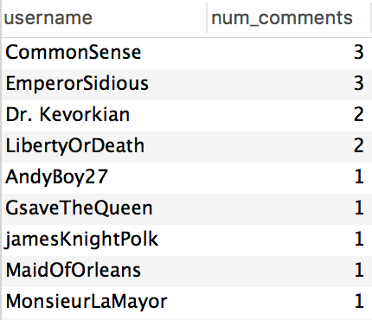

**#view for number of posts by each person**

create view number_of_posts as

select username, count(*) as "num_posts"

from posts

group by username

union

select username, 0 as "num_posts"

from users

where username not in(select distinct username from posts)

order by num_posts desc, username

;

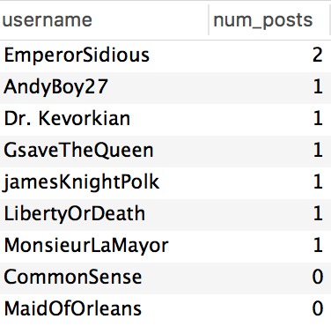

**#View to add posts and comments for each user to sum up activity**

create view number_of_activity as

(

select username, sum(num_posts)+sum(num_comments) as num_activity

from number_of_comments natural join number_of_posts

group by username

order by num_activity desc, username

);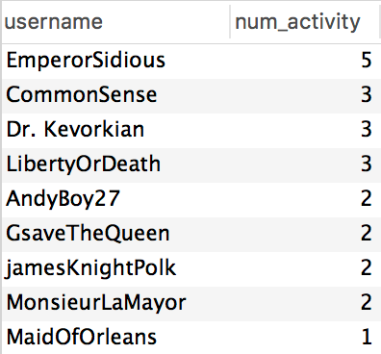

**#Sql query to do this without views**

select username, sum(num_posts)+sum(num_comments) as "num_activity"

from (

(select c_username as "username", count(*) as "num_comments"

from comments

group by username)

union

(select username as "username", 0 as "num_comments"

from users

where username not in(select distinct c_username from comments)

order by username) ) as Table1 natural join

(select username, count(*) as "num_posts"

from posts

group by username

union

select username, 0 as "num_posts"

from users

where username not in(select distinct username from posts)) as Table2

group by username

order by num_activity desc;

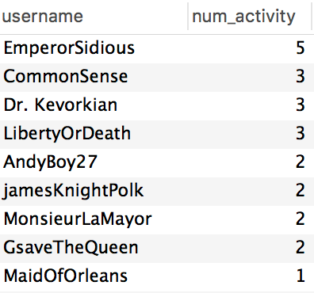

**#View showing total posts,comments, and sum activity in one**

**#Using natural joins**

create view total_activity as select * from number_of_posts natural join number_of_comments natural join number_of_activity;

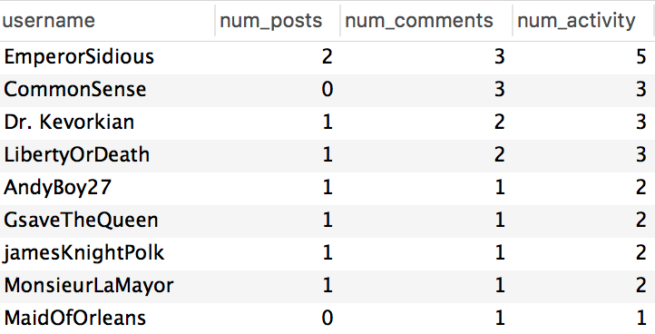

**#Show all users with more comments than posts (using previously created views)**

select username, num_posts, num_comments

from number_of_comments natural join number_of_posts

where num_comments > num_posts

group by username;

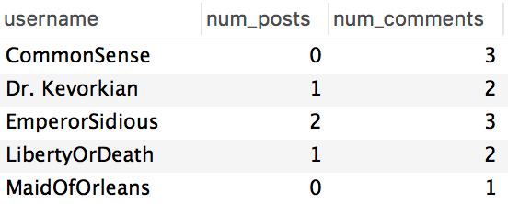

**#Show all users with more comments than posts without using views**

select username, num_posts, num_comments

from(

((select c_username as "username", count(*) as "num_comments"

from comments

group by username)

union

(select username as "username", 0 as "num_comments"

from users

where username not in(select distinct c_username from comments)

order by username))

as Table1

natural join

((select username, count(*) as "num_posts"

from posts

group by username)

union

(select username, 0 as "num_posts"

from users

where username not in(select distinct username from posts)

order by username))

as Table2

)

where num_comments > num_posts

group by username;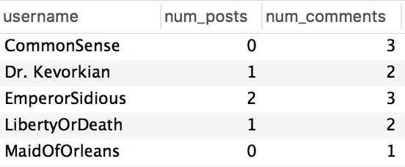

**ALL TABLES**

User Table:

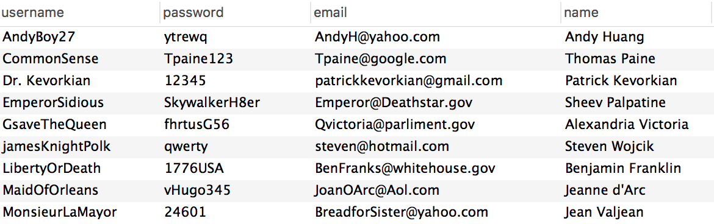

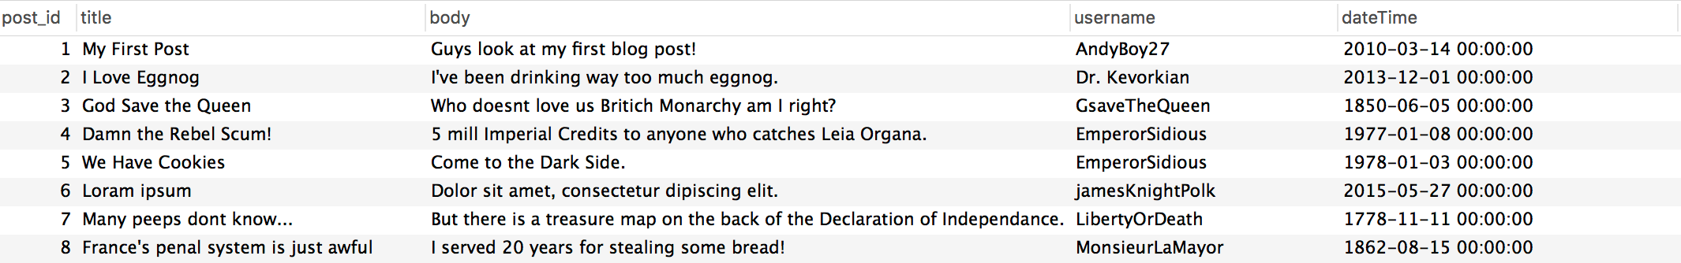

Post Table:

Comments Table: